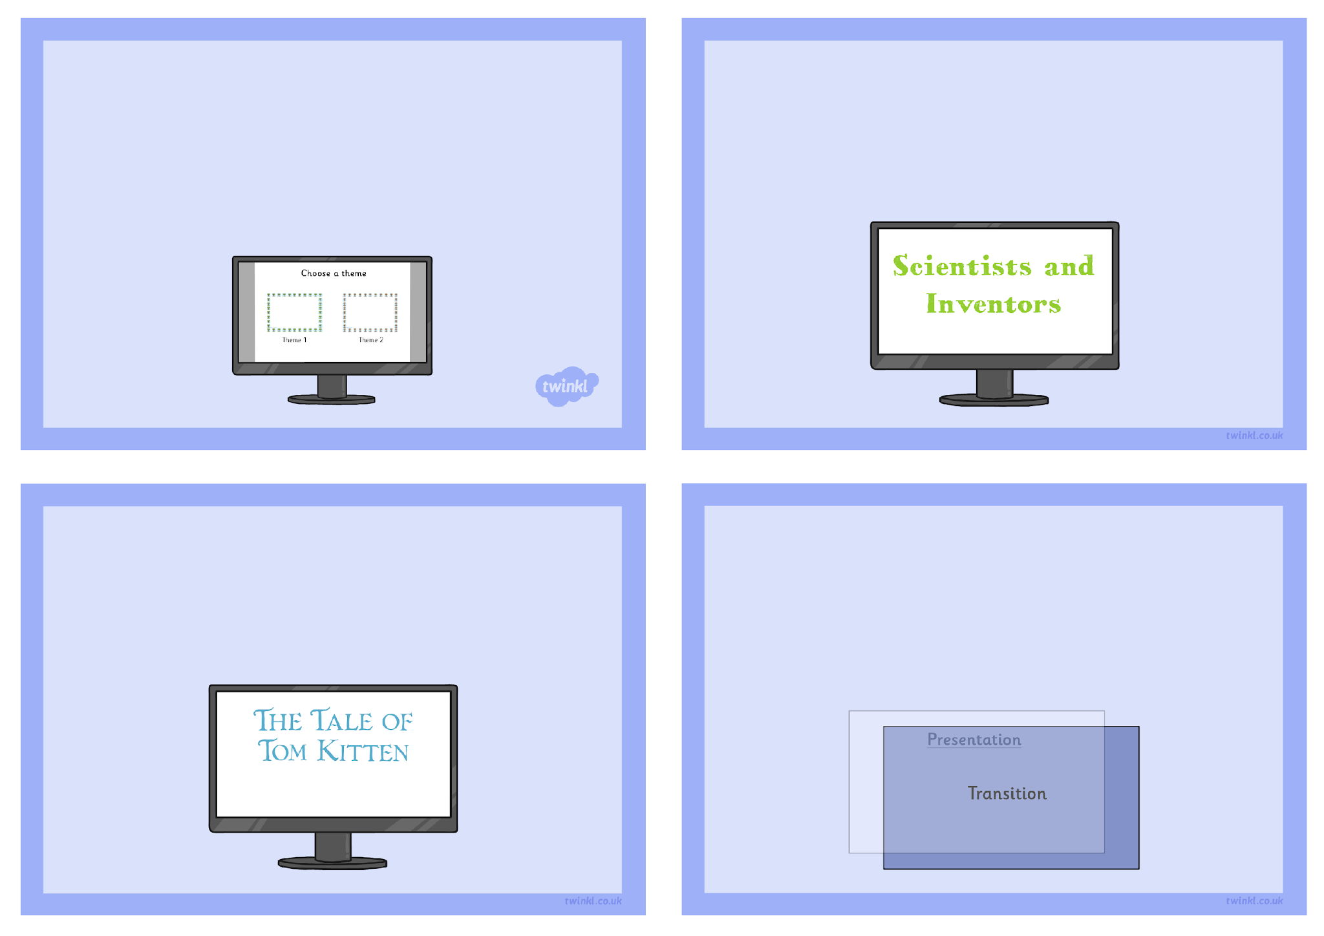
Theme, Transitions and Animation
Challenge Cards
You are to create a presentation about a Science topic you have learnt about recently. Choose a theme and create a title page.
You could create some slides to go with it.
You are to create a presentation to tell a story. Choose a theme and create the title slide.
You could create some slides to go with it.
Create a 5 slide presentation, choose a theme and give it the title “Slide transitions.” Use 2 slide transitions you like and 2 you don’t and after each transition, on the next slide, explain what you like or don’t like about the transition.


Create a single slide presentation and use single words with animations to explain how the animations make the text boxes appear on the slide.

